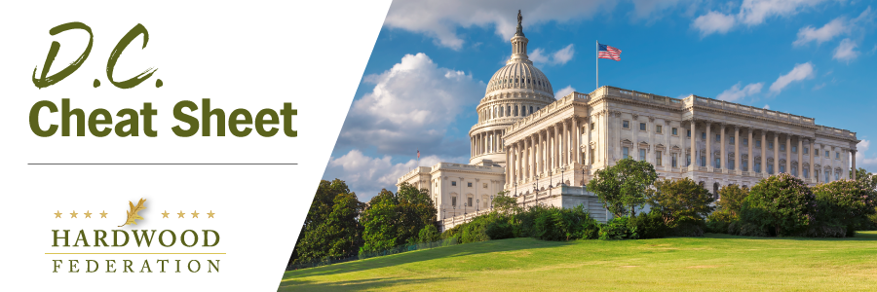

Quick Updates from Your HF Team

Potential Railway Strike Takes Over Hill Agenda

With only eight calendar days remaining before a December 9 deadline tolls on a labor agreement, Congress has stepped in to avoid a strike that could derail supply chains. On Wednesday, the House passed legislation to impose a contract on the railroads and unions. As Senate Democrats continue to plan a path forward, a senior GOP senator informed Federation staff on Wednesday that he believed the measure would ultimately pass with a bipartisan vote. These actions consistent with the message conveyed on November 28, when the Federation, U.S. Chamber of Commerce and more than 400 industry allies sent a letter urging Congress to act sooner rather than later.

Administration Classifies Northern Long-Eared Bat as “Endangered”

On November 29, 2022, the U.S. Fish and Wildlife Service (USFWS) formally reclassified the northern long-eared bat (NLEB) as endangered under the Endangered Species Act, based on challenges posed by white nose syndrome. Although the agency took pains to note that it will take steps to mitigate adverse economic impacts, the Federation plans to reach out to the USFWS for further information and track the implementation process. On December 2, the agency will conduct live webinar to outline next steps. Click here to learn more about the NLEB.

House Zeroes-In on Leadership Slots for 2023

Although the new Congress won’t convene until January, House Democrats have wasted little time clearing the decks for a new generation of leadership to guide the caucus in 2023. Here’s the line-up resulting from the Wednesday elections:
- With Speaker Pelosi’s (D-CA) announcement that she will step down from the party’s leadership post, House Democrats elected Rep. Hakeem Jeffries (D-NY) in an unopposed bid to become Minority Leader.
- Rep. Katherine Clark (D-MA) also won her bid for House Minority Whip; and
- Rep. Pete Aguilar (D-CA) was tapped to become the party’s number three in the House as conference chair.
House Republicans are facing more of an uphill climb than their Democrat colleagues, with GOP Leader Kevin McCarthy (R-CA), who needs near-unanimous support from his caucus in a thinly divided chamber, facing five or so caucus members who haven’t yet endorsed him for Speaker. That said, Reps. Steve Scalise (R-LA) and Tom Emmer (R-MN) won their respective bids for Majority Leader and Majority Whip during a vote on November 15.

