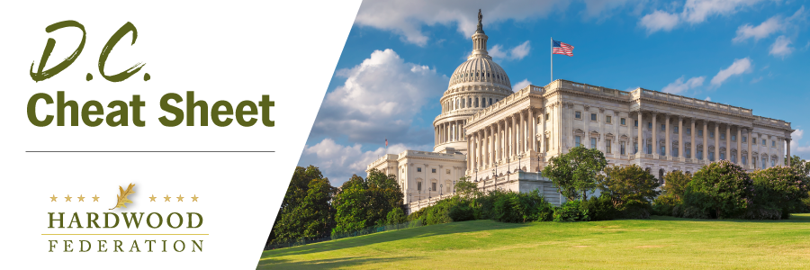

Quick Updates from Your HF Team
Congress Moves Wood Products Carbon Study
The wood products industry is currently advocating for a focused study within the Forest Products Laboratory (FPL) that will accurately quantify the sector’s greenhouse gas (GHG) reductions and potential for wood products, thereby providing a tool to give industry credit for its environmental benefits. Before breaking for the August recess, Senate appropriators included directions to USDA to move forward with a study to conduct a detailed study on the amount of carbon stored annually in wood products within the 2024 spending bill. Now that the sought-after program is included in the legislation, the coalition will advocate that the carbon study makes it across the finish line when lawmakers approve the final FY 2024 budget.
Hardwoods, Business Community Advocate for Permitting Reform
On August 7, the Hardwood Federation participated in a coalition meeting led by the U.S. Chamber of Commerce to talk about activities related to federal permitting reform, focusing on efforts to streamline the process across multiple agencies including EPA and the Department of Transportation, among others. The Chamber raised alarm bells related to the Administration’s proposal to alter National Environmental Policy Act (NEPA) federal permitting requirements that would add red tape to a process that already takes up to four and a half years to complete. The hardwood sector is joining the Chamber in comments pushing back on the proposal, which may lay the groundwork for a court fight or new legislation.
House Lawmakers Take Wildfire Hearing Outdoors, and on the Road
Although Congress remains in recess through the Labor Day holiday, House Natural Resources Committee Chairman Bruce Westerman (R-AR) will lead an outdoor field hearing on Friday, August 11 at Yosemite National Park to spotlight active forest management and wildfire risk. Witnesses will range from recreational service operators in the Yosemite region to representatives from the California Farm Bureau and cattlemen groups, focusing on the catastrophic wildfires that result from misguided environmental policies. To watch the hearing tomorrow at 11 AM PT, view the committee’s livestream here.

