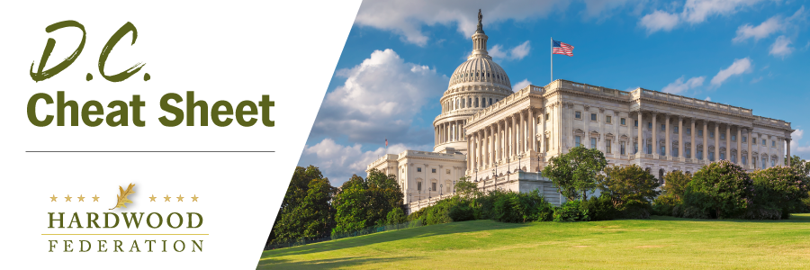
Quick Updates from Your HF Team

Reps. Tiffany (R-WI) and Kuster (D-NH) Introduce Hardwood Access Bill
As the year winds up, Reps. Tom Tiffany (R-WI) and Annie Kuster (D-NH) introduced The Hardwood Access Program, a hardwood industry-specific bill intended to grow demand for hardwood products, specifically, in the form of a Hardwood Access Program (HAP). The bipartisan legislation, if passed, would authorize grants totaling $25 million over a five-year period and fund proposals that bolster domestic industry efforts and research that directly supports end-user information on the benefits of hardwoods. With a House bill in hand, the Federation team will take another run at finding sponsors for a companion bill on the Senate side. Although fiscal constraints will make it very difficult to move HAP legislation as part of the farm bill, the legislation will serve as a high-profile vehicle to educate Congress on the benefits of hardwood products. This will lay the groundwork for enactment in future years.
USFS Announces Plans to Revamp Forest Management Plans, Creates Uncertainty
On December 19, the Federation participated in a call with U.S. Forest Service (USFS) Chief Randy Moore rolling out a Notice of Intent, subject to comment through February 2, 2024, to “amend all 128 forest land management plans to conserve … old-growth and mature forest conditions on national forests… nationwide.” Chief Moore stated that the proposed amendment will help the agency focus on the impacts of wildfires and climate change and serves as a next step following development of a comprehensive inventory of old growth and mature forests, showing a decline in acreage under the agency’s purview. Unfortunately for industry, this could motivate federal regulators to clamp down on logging activity in an effort “to restore” lost acreage of mature and old growth forests.
NOTE TO OUR READERS: The DC Cheat Sheet will next publish on Thursday, January X, 2024. The Federation team wishes you a Happy Holiday!

