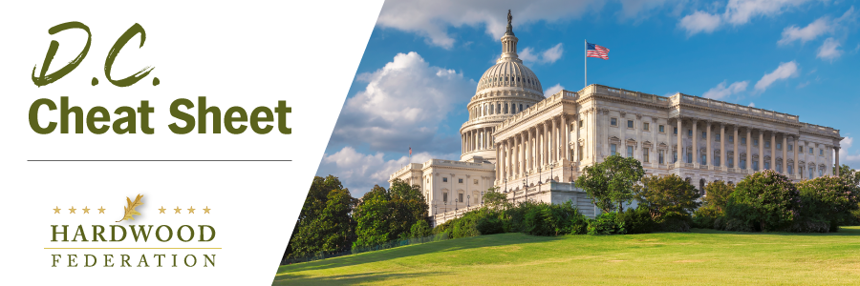

Quick Updates from Your HF Team

Fly-In 2023!! REGISTER TODAY!
The Hardwood Federation Fly-In is back in 2023!! Make plans today to join us in Washington, D.C. June 13-15. Events will kick off with a welcome reception on the evening of Tuesday, June 13 followed by a full day of meetings on the Hill with your Congressmen and Representatives…the Federation team will fully brief you over breakfast on key talking points and meeting logistics. We will host a PAC reception Wednesday night for our friends on the Republican side of the aisle and celebrate the day’s achievements over dinner. The Fly-in wraps up with a Thursday morning breakfast event recognizing the Democrats that support the hardwood industry. Check out the full schedule of events. Registration is now open. The Federation has arranged for a limited number of rooms at a special rate at our host hotel, the Washington Hotel Monaco. Be sure to reserve yours today. You can sign up for the Fly-In and reserve your room HERE!

Key Farm Bill Players Named, Congress Finalizes Ag Committees
Congressional leaders have finally filled the ranks for the House and Senate Agriculture Committees which will steer the mass farm bill through Congress. Fortunately, industry keeps a roster of bipartisan allies and can look forward to working with champions such as Rep. GT Thompson (R-PA), chairman of the House Ag Committee as well as senior and influential Democrats on the panel, such as Ranking Member David Scott (D-GA), and committee members Jim Costa (D-CA) and Abigail Spanberger (D-VA), just to name a few. On the Senate side, the Federation has worked closely with Ag panel leaders, Chair Debbie Stabenow (D-MI), who has announced her retirement in 2024, and Ranking Member John Boozman (R-AR). We look forward to continuing good relations with these leaders on industry issues and will keep you posted on progress as the bill moves forward.
Hardwood Industry, Ag Sector Allies Rallying Behind SHIP IT Act
While House lawmakers roll out bills that address ongoing supply chain challenges, the “Safer Highways and Increased Performance for Interstate Trucking (SHIP IT) Act” (H.R. 471) is attracting early support from the Federation, American Farm Bureau and other allies aiming to untangle the country’s supply chains. The legislation kills two birds with one stone, addressing driver shortages through training incentives and rolling back red tape related to hours-of-service rules. Industry allies, Reps. Dusty Johnson (R-SD) and Jim Costa (D-CA), are leading the charge on the bill and expect it to move as part of a larger “supply chain package” in the spring.

