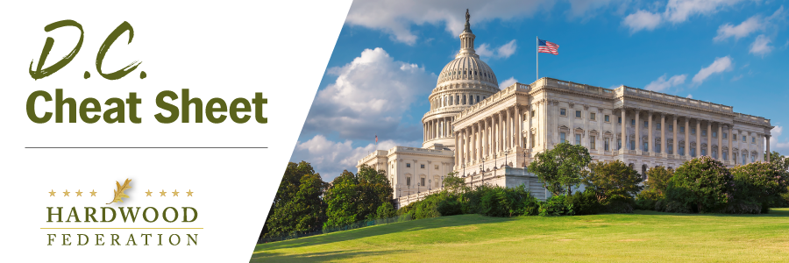
Quick Updates from Your HF Team

Breaking News--Hardwood Access Legislation Gets a Bill Number
The HF-crafted Hardwood Products Access and Development Program Act was assigned the bill number-- H.R. 6880. Keep your eyes open for our grass roots alerts in the coming days to promote the bill in our efforts to recruit bipartisan Congressional support.
USFS Proposes to Amend Land Management Plans
On December 20, the USFS released a notice stating its intent to amend all land management plans in an attempt to maximize conservation of old growth forests. The latest agency action ignores industry comments submitted in 2023, urging federal regulators to avoid treatment of old growth and mature forests in a manner that undermines forest management. The Federation is reviewing details related to the proposal and exploring submission of joint comments to be signed by a broad spectrum of forest products industry groups.
Federal Spending Deadlines Loom Large
Congress kicked off the second session of the 118th Congress on a relatively high note this week, reaching a broad deal between the House and Senate on so-called “top line” budget numbers, which would cap funding of federal programs at about $1.6 trillion during Fiscal Year (FY) 2024. Despite the deal, which reduces the possibility of a federal shutdown, Congress only has eight calendar days in which to pass four appropriations bills, including funding for USDA, that will expire on January 19, per the two-track continuing resolution that currently funds government operations at last year’s levels. Under the current CR, the second funding deadline falls on February 2 and covers six appropriations bills, presenting lawmakers with another hurdle to jump before the possibility of a shutdown in early 2024 can be completely ruled out.
Tax Chairs Prepare Package for Tax Filing Season
While ironing out the details of an umbrella budget for FY 2024 has proven to be elusive (see article above), congressional tax writing chiefs, Sen. Ron Wyden (D-OR) and Rep. Jason Smith (R-MO) are working on a framework that would restore some of industry’s top business priorities in exchange for a more robust child tax credit, a popular item for most Democrats. The tax chiefs are focusing on restoration of business interest deductions, the R&D tax credit and full expensing of equipment for possible passage prior to the beginning of the tax filing season. HF will keep you posted on developments as they unfold.
Make your voice heard! The Hardwood Federation wants your feedback on federal policies that impact your business. To identify the industry’s top priorities for 2024, please click here.

