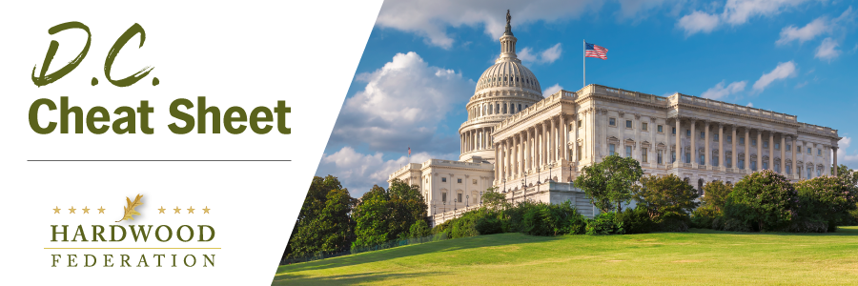

Quick Updates from Your HF Team

Congress Cancels Memorial Day Recess, Tackles Debt Ceiling
Congress remains in session this week to hammer out a bill that will raise the federal debt ceiling and prevent the federal government from defaulting on its obligations to pay interest on all its red ink. The extended debate impacts the hardwood industry’s agenda by not only causing some delays in moving the farm bill forward, for example, but also by creating an environment whereby lawmakers will be especially vigilant in debating the fiscal parameters around the farm bill and Fiscal Year (FY) 2023 appropriations bills to fund the federal government beyond September 30. The Federation will keep you posted on how the broader legislative agenda may impact the industry’s priorities, ranging from supply chain issues to tax matters tied to small business.
HF Gears Up for USDA’s Latest Proposal on Forest Management
The USFS has released an Advance Notice of Proposed Rulemaking (ANPRM) requesting feedback from stakeholders on next steps to implement an Executive Order to strengthen the nation’s forests, issued in April 2022. Shortly thereafter, the Federation submitted comments on a “Request for Information,” also from the USFS on mature and old growth forests, during which time industry advocated against a “one size fits all” regulatory definition. The deadline for the latest round of comments currently falls on June 20 and may be extended. That said, industry arguments will center on the necessity of forest management as an indispensable tool to promote and maintain “climate resilient” forests, the over-arching goal of the Administration’s current exercise.
Fly-In 2023 Takes Shape
With only two weeks left before the Fly-In, the Federation team continues to finalize meetings with federal lawmakers, written materials that will drive those discussions, and receptions on Capitol Hill to thank the industry’s legislative champions. Although a moving target that changes by the day, so far 60 industry leaders are scheduled to meet with more than 60 individual lawmakers and their staff. In addition to the meetings on the Hill,14 Republicans have signed up for the Capitol Hill Club reception on Wednesday, June 14 while seven Democrats have agreed to participate in the HFPAC breakfast event on Thursday, June 15. For a complete list of events, please click here.

Mark Your Calendar! The Federation Fly-In is Back, June 13 – 15, 2023
To sign up and reserve your room, please click HERE!.

