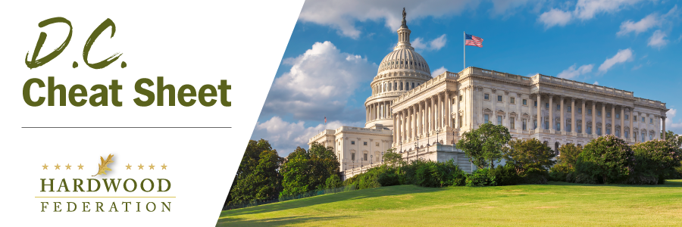

Quick Updates from Your HF Team

Congress Returns to the States for the Fourth

As Congress breaks for the Fourth of July Recess until the week of July 10, be on the lookout for your federal lawmakers as they make the rounds of parades and barbecues. In the event you see your elected officials, be sure to echo the Federation’s key “asks” driven home during the June Fly-In:

- Farm Bill – Congress must establish a grant program educating the public about the benefits of hardwood products, especially recognition of the carbon capture value of hardwood products.
- Taxes – Congress must make permanent 100% expensing of industrial equipment and the 20% deduction for small business. Congress should also restore full deductibility of business expenses.
- Transportation – Congress must pass a “supply chain package” that creates flexibility for truck weights, grows the dwindling pool of trucker drivers and expedites implementation of ocean shipping reforms.

USFWS Proposes to Tighten ESA Rules

On June 21, the USFWS proposed three modifications to ESA standards in an attempt to address what the agency describes as weakened protections implemented by the previous Administration. The proposals seek to:

- Specify that the agency may not consider economic impacts when making reclassification, listing and delisting decisions;
- Reinstate the blanket 4(d) rule while retaining the option for the Service to adopt a species-specific 4(d) rule;
- And revise the interagency consultation process.

The Federation is preparing comments on the proposals, which are due in late August.
.
House Tax Package Moves to Front Burner

When the House Ways and Means Committee passed a tax package on June 13, it launched legislation that serves as a vehicle for some of the hardwood industry’s top priorities. Included in the mix are provisions that extend full expensing of equipment through the end of 2025 and restoration of business interest deductibility, known in accounting-world as Earnings Before Interest, Depreciation and Amortization (EBITDA), also through 2025. House leaders hope to move the package to the House floor before the August recess.

