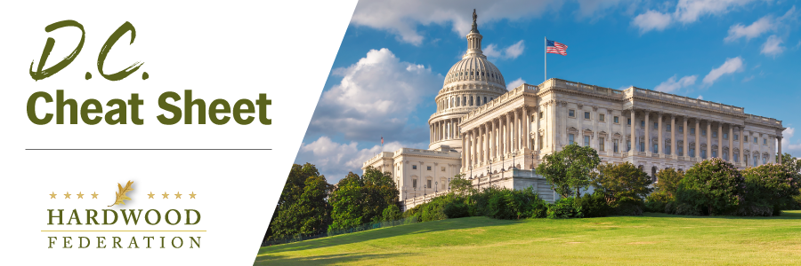

Quick Updates from Your HF Team

House Transportation Panel Delivers Supply Chain Package, Floor Vote Uncertain
On May 23, House transportation panel members approved several measures to strengthen the nation’s supply chain and help prevent future disruptions. Commenting on the committee’s action, Chairman Sam Graves (R-MO) stated that the supply chain package will remove “regulatory barriers, improve supply chain efficiency, and promote smarter infrastructure investment.” The following are some take-aways related to the legislation which may move on the House floor this summer.
- Fortunately, the package incorporates key portions of the industry-supported SHIP IT Act (H.R. 471). This includes a provision that remedies the trucker shortage by cutting red tape to qualify for a Commercial Drivers’ License (CDL), a pilot program whereby states can opt into increasing truck weight limits to 91,000 pounds, and funds to provide more parking facilities for truckers to improve highway safety.
- The package also incorporates H.R. 1836, the Ocean Shipping Reform Implementation Act of 2023, championed by Rep. Dusty Johnson (R-SD). This bill strengthens the Ocean Shipping Reform Act of 2022 and empowers the Federal Maritime Commission to review complaints about market manipulation and anti-competitive operations of maritime exchanges.
- There are two noticeable omissions to the current package. The Federation-supported Drive Safe Integrity Act (H.R. 3408), which aims to boost participation in the Safe Driver Apprenticeship Pilot program, didn’t make the cut. Also, the Strengthening Supply Chains through Truck Driver Incentives Act (H.R. 2450), legislation that authorizes lucrative tax credits to new and existing truck drivers to address the trucker shortage, failed to make it into the package.
Fortunately, the Transportation Committee plans to conduct another working session on key supply chain bills in September, giving industry another bite at the apple. As the Federation continues to monitor House floor activity this summer, stay tuned for a possible “call to action” where you can make your voice heard and pass legislation that will help the sector.
Mark Your Calendar! The Federation Fly-In is Back, June 13 – 15, 2023
To sign up and reserve your room, please click HERE!.

