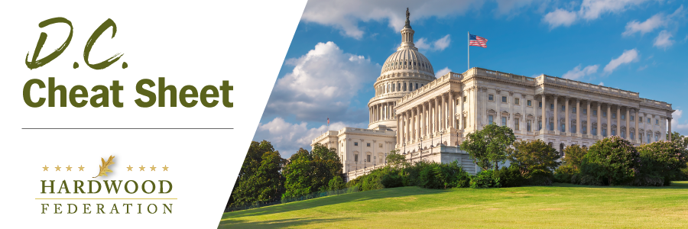

Quick Updates from Your HF Team
House GOP Gives Nod to Rep. Scalise for Speakership, Battle Begins
With the House GOP having cleared the first hurdle to select a new Speaker by giving Rep. Scalise (R-LA) a thumbs up as the new House leader, Mr. Scalise and his allies now begin the battle to secure approximately 217 votes, depending on the number of absentees, on a House floor vote to close the deal. So far, House leaders have not scheduled a floor vote, signaling that Mr. Scalise has yet to gain assurances that he will win support from 217 members. On Wednesday, House Republicans gathered at the Capitol to cast votes for their preferred candidate, delivering a 113-99 victory to Rep. Steve Scalise (R-LA) over Rep. Jim Jordan (R-OH), the other major contender. In addition to facing important budget issues, the House election gained a new sense of urgency this week in the wake of the terror attacks on Israel on Saturday, where lawmakers may deliver a legislative response in the form of an aid package.
Sen. Manchin Reintroduces Forest Management Bill
In late September, Senate Energy & Natural Resources (SENR) Committee, Chairman Joe Manchin (D-WV) and Ranking Member John Barrasso (R-WY) reintroduced the “Promoting Effective Forest Management Act of 2023” (S. 2867), bipartisan legislation that will reduce wildfire risk and improve forest health by using existing resources. The bill directs the National Forest Service (NFS) and Bureau of Land Management (BLM) to establish yearly acreage targets for mechanical thinning, mandating a scientific basis for changes to definitions of old growth and mature forests and address shortages plaguing the logging workforce. Senate leaders have referred the bill to the SENR where a path forward is not known at this time. To view a one-page summary of the bill, please click here.

House Speaker Fight Delays Tax Debate
When the House Ways and Means Committee passed a tax package on June 13, it created a generous timeframe on the 2023 calendar for House lawmakers to pass legislation that serves as a vehicle for some of the hardwood industry’s top priorities. Unfortunately, the internal struggle dividing the House GOP has suspended meaningful floor activity during crucial legislative work weeks in October, delaying passage of key industry tax provisions. These include full expensing of equipment until 2027 and restoration of business interest deductibility, known in accounting-world as Earnings Before Interest, Depreciation and Amortization (EBITDA) until 2026. The Federation recently signed a letter led by the National Association of Manufacturers urging Congress to pass these priorities.

