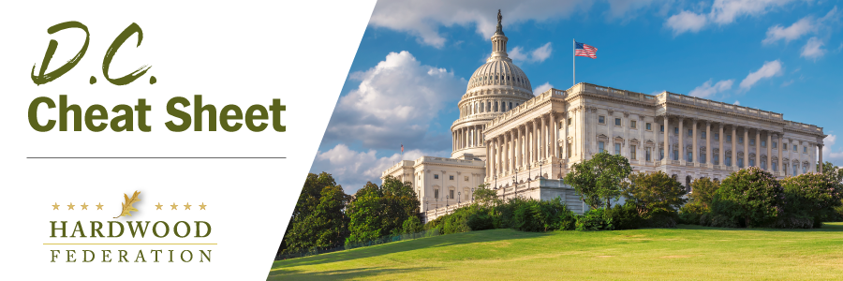

Quick Updates from Your HF Team
Farm Bill Timing Remains a Moving Target
As Congress reconvenes this week after the August recess, lawmakers are pushing back timelines that once framed the farm bill debate. House Ag Committee Chair and hardwood champion GT Thompson (R-PA), previously aimed to have draft text available in early September but is now holding off on sharing text for the farm legislation until leadership commits to a window to move a bill on the House floor. The Senate is similarly positioned, with both chambers hoping to limit challenges to agreed upon language. The looming deadline for federal funding that falls on September 30 also threatens progress. If a budget agreement cannot be reached, keeping government open will require a temporary “stopgap” to avoid a partial shutdown, a measure once considered relatively straightforward but now bogged down by issues such as aid for Ukraine and border security. The HF team participated in a call with House Ag Committee staff on September 11 where it was emphasized that resolving the federal funding issue is a prerequisite for clarifying a new timeline for the farm bill.
Industry Advocates Status Quo for Air Quality Standards
On September 7, the Hardwood Federation joined the U.S. Chamber of Commerce and 32 other industry groups in a letter to EPA chief Michael Regan urging the Administration to retain the current standard for fine particles (PM 2.5) and not move forward with a proposed, stricter standard. The trade groups point out that while the current standard continues to be implemented, fires and unpaved roads have surpassed industrial sources, such as sawmills and power plants, as major drivers of air pollution. Industry states that the economy, already in a fragile state, should not assume the burden of compliance costs, especially for a rulemaking that’s discretionary, as opposed to statutory or court driven, on the part of the Administration.
New Labor Contract Stabilizes West Coast Port Operations

After spending more than a year in limbo, dockworkers represented by the International Longshore and Warehouse Union signed a contract with west coast port operators, ending a stalemate that has exacerbated supply chains tied to the import and export of goods, including hardwood products, through the nation’s largest ports. Since May 2022, when talks first began, many businesses have rerouted their cargo through less convenient ports on the east coast, adding increased shipping costs during an uncertain and inflationary economic environment. The new contract runs through 2028, adding some stability to industry’s supply chain challenges.

