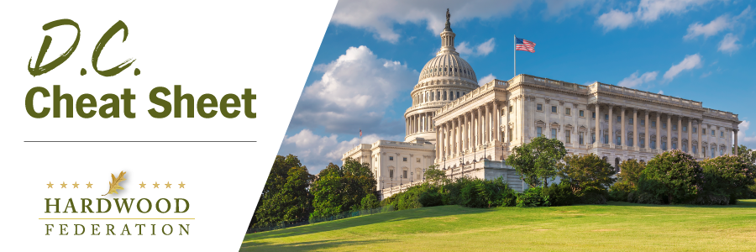

Quick Updates from Your HF Team

Federation Fans Out on the Farm Bill
As the process of drafting the 2023 Farm Bill moves forward, HF continues to share the industry’s top farm bill priorities with key ag leaders on the Hill. These include ongoing visits and discussions with staff in the offices of House Ag Committee Chair GT Thompson (R-PA), Senate Ag Chair Debbie Stabenow (D-MI), Senate Ag Ranking Member John Boozman (R-AR), Senate Minority Leader Mitch McConnell (R-KY), committee member Sen. Mike Braun (R-IN), John Fetterman (D-PA) and Tommy Tuberville (R-AL), and several House Committee Member Offices.
Empire State Forest Products Association Weighs in On Farm Bill
On April 14, House Agriculture Committee Chairman GT Thompson (R-PA), hosted a Farm Bill listening session in Binghamton, NY and was joined by New York Congressman Marc Molinaro (R-NY-19) and Rep. Nick Langworthy (R-NY-23) along with several other bipartisan members of the panel. John Bartow, Executive Director of the Empire State Forest Products Association (ESFPA) delivered remarks before the panel, sharing and supporting several Hardwood Federation priorities including the importance of recognizing the carbon storage value of wood products, increasing export promotion dollars and funding for USDA’s biomass energy program. The event brought together a variety of stakeholders ranging from farmers to agribusiness owners to offer recommendations as the 2023 Farm Bill moves forward.
House Supply Chain Caucus Convenes
On April 19, leaders of the House Supply Chain Caucus, led by Reps. David Rouzer (R-NC), Dusty Johnson (R-SD), Colin Allred (D-TX), and Angie Craig (D-MN), conducted a roundtable discussion to outline remedies for ongoing supply chain challenges. The Hardwood Federation was on hand at the briefing along with about 50 other stakeholders—an unusually large number of folks in attendance which underscores the fact that supply chain challenges are evident across the economy. Lawmakers focused on the Federation-supported SHIP IT Act, which includes a number of policy proposals to entice new truck drivers to take up driving as a career. The bill also includes a truck weight pilot program for heavier trucks to travel on the nation’s interstate highway system and may move with a broader "supply chain package" this spring.

