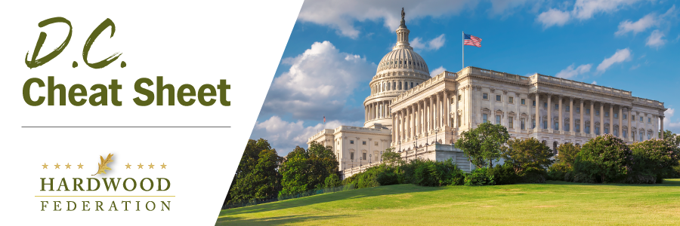

Quick Updates from Your HF Team

Bipartisan Lawmakers Fight to Restore Business Interest Deduction

On April 20, Sens. Shelley Moore Capito (R-WV) and Kyrsten Sinema (I-AZ) and Reps. Adrian Smith (R-NE) and Joe Morelle (D-NY) introduced the American Investment in Manufacturing (AIM) Act. This bipartisan legislation would restore the full suite of deductions for business loans, known as Earnings Before Interest, Depreciation and Amortization (EBITDA), thereby creating business certainty and promoting investment. Unfortunately, tax breaks for depreciation, which includes expensing of equipment (see below) and amortization were dropped in 2022. The Hardwood Federation urges Congress to restore these important deductions and pass the AIM Act.

Manufacturers Focus on 100% Expensing of Equipment

In more tax news, although formal legislation has not yet been introduced, the hardwood industry and broader manufacturing sector have identified restoration of the 100% expensing of equipment deduction as a high priority for the 118th Congress. Bonus depreciation serves as a powerful pro-growth tool by reducing the after-tax cost of long-lived capital equipment purchases. Unfortunately, this provision began to phase down to 80% in 2023. According to current law, bonus depreciation will continue to scale down in 20% increments over the next four years, unless Congress intervenes, thereby undermining business certainty.

USDA Issues “Old Growth Forest” Framework, Notice of Proposed Rulemaking
On April 20, USDA released a report on old growth forests and a related Advance Notice of Proposed Rulemaking (ANPR) soliciting feedback from stakeholders on how the USDA should use current policies to manage forests in a manner that promotes climate resilience. In August 2022, the Federation submitted comments to USDA’s Request for Information related to definitions for “old growth forest,” advocating against a “one size fits all” definition. This week’s action is the latest from USDA, arising from Executive Order 14072, “Strengthening the Nation’s Forests, Communities and Local Economies”, issued in April 2022. Stay tuned for updates as the Federation develops comments to USDA outlining a framework for forest management policies as they impact climate resilience.

Mark Your Calendar! The Federation Fly-In is Back, June 13 – 15, 2023
To sign up and reserve your room, please click HERE!.

