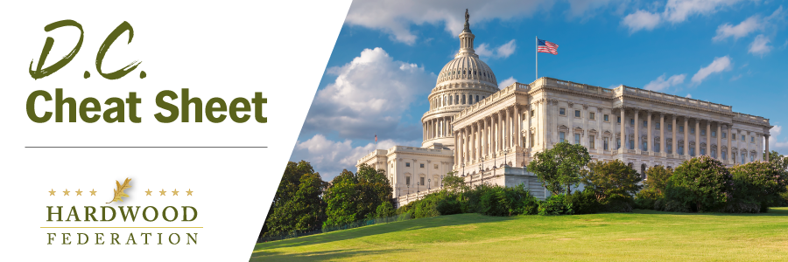
Quick Updates from Your HF Team

EPA Releases Stringent Air Quality Standard
On Wednesday, EPA lowered the final air quality standard for PM 2.5, also known as “fine particulate matter,” from 12 ug per cubic meter to a more stringent 9 ug, a level which could impose up to $900 million in compliance costs on the wood products sector. Unfortunately, federal regulators are targeting the wrong source of emissions, shifting a massive burden to industry that could otherwise be addressed by forest management and an accompanying reduction in wildfires, which are the source of 43% of emissions. Industry groups, including the U.S. Chamber of Commerce, among others, will now consider legal and legislative remedies to push back against the new rule.
Tax Package Sails into Senate Limbo
Despite the fact that that the Tax Relief Act passed the House on January 31 by an overwhelming, bipartisan majority – 357 to 70 under expedited procedures - the package of business tax breaks and childcare incentives confronts some challenges in the Senate. Whereas many GOP senators have expressed concern about the overall cost of the Child Tax Credit (CTC) and its impact on the budget, champions of the provision support the credit, arguing that it focuses on lower income families. Despite the bill’s relatively speedy progress in the House, a path forward in the Senate is not certain at this time.
Senators Aim to Streamline Import Enforcement
On February 2, a trio of GOP lawmakers, Sens. Wicker (R-MS), Ricketts (R-NE) and Britt (R-AL), introduced the Strengthen Wood Products Supply Chain Act, a bill intended to expedite enforcement of wood import violations. Currently three federal agencies, including USDA’s animal and plant health division, the U.S. Wildlife and Fisheries Service, and Customs and Border Patrol share responsibility for inspecting wood product imports to screen for illegally sourced lumber. The bill’s supporters claim that the excess red tape causes unnecessary delays, adding to already existing supply chain bottlenecks. With the House version of the bill scheduled for a hearing on February 14, the bill is gaining some traction in both chambers.

Hardwood Industry Outlines Top Policy Priorities for 2024
On February 5, the Hardwood Federation released its survey ranking the top public priority items for the industry. As in past years, all issues surveyed scored on the upper end of the rankings, demonstrating that each issue has a major impact on the industry. Coming first this year was promoting the “environmental benefits of hardwood products” followed closely by a concern with federal regulations. Tax issues scored high as well, with several respondents pointing out that the estate tax and 100% depreciation of equipment were essential to the success of their operations. Thanks to all who participated in this year’s survey.
Mark Your Calendar Today! The Hardwood Federation has scheduled Fly-In 2024 for Tuesday, May 21 to Thursday, May 23. Save the dates and come to Washington to make your voice heard on Capitol Hill! Stay tuned for details related to registration information and Fly-In agenda.

