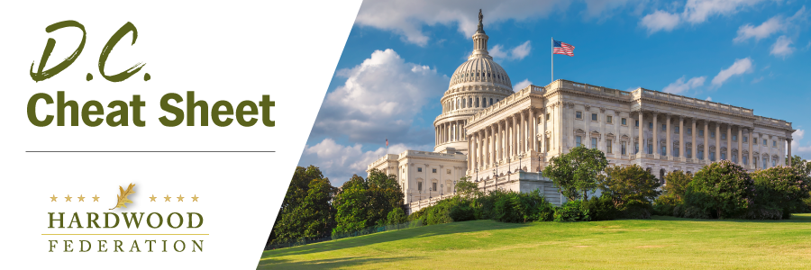

Quick Updates from Your HF Team

Save the Date! The Federation Fly-In Takes Off in June
Hardwood Federation Fly-in 2023-We’re Back! The Hardwood Federation Fly-In returns in 2023! We will be gathering in Washington, D.C. from June 13-15, meeting with your Senators and Congressmen, networking with your peers and seeing the sights of D.C. More details will be shared in the near future, but for now, save those June dates…we hope to see you in D.C.!

Tax Rate Tug-of-War to Emerge in the New Congress

Because many of the tax cuts enacted at the end of 2017 are set to expire in 2025, Congress is laying the groundwork for a show-down over revenues during the next two years. Emboldened by a tax hike on corporations included in the Inflation Reduction Act, many Democrats will place small business deductions in the crosshairs as a means of raising revenue. The Federation and its allies in the small business community are already planning to go on offense by pushing full repeal of the estate tax early in the session. The Federation will keep you posted on developments on the tax front as events unfold.

House Ag Chair GT Thompson Kicks Off Farm Bill 2023

On Friday, January 13, Ag Committee Chair GT Thompson (R-PA) convened a listening session at the Pennsylvania Farm Show to review key topics for the farm bill. With spending concerns taking center stage in most legislation that will move in the House this session, Rep. Thompson stated that he would work with the Budget Committee to outline the bill’s parameters, thereby avoiding potential gridlock over federal spending issues moving forward. Hardwood Federation member association the Pennsylvania Forest Products Association was represented by Executive Director Matt Gabler who provided input on behalf of the forest products community, highlighting areas of importance to the hardwood sector in the Farm Bill. Gabler noted. “We are looking to this Farm Bill as an important opportunity to optimize the management of federal lands, improve the outreach and educational materials available to the public, and ensure that our commodities effectively reach domestic and foreign consumers.”

