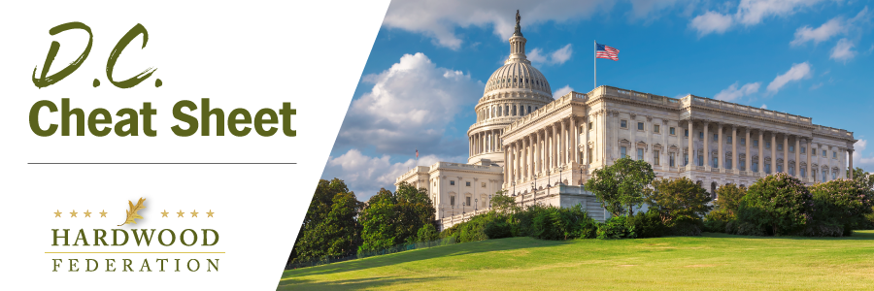

Quick Updates from Your HF Team

Corporate Transparency Act to Impose Business Disclosure Mandates
Beginning in January, the Corporate Transparency Act, legislation intended to target money-laundering operations, is poised to trigger an avalanche of reporting requirements, including disclosure of the personal information of owners of newly formed businesses. This could have the net effect of mandating 32 million new reports from the private sector, a move being described as a massive “data grab” that effectively presumes criminal activity on the part of the nation’s business owners. Violations could trigger huge fines and jail time. With a lawsuit and legislation in the works that could rescind the law or at the very least blunt its implementation, the Federation will keep you posted on developments that will impact the industry.
Permitting Reform Gains Momentum
When Congress voted in early June to suspend the debt limit for two years, thereby avoiding possible default on the nation’s bills, lawmakers included some key streamlines to the federal permitting process in the fine print, consistent with advocacy from the hardwood industry and its allies. The deal includes setting a two-year limit on National Environmental Policy Act (NEPA) permitting, a process which now takes on average four and a half years to complete and has long tied up forestry, construction and other commercial projects. The new law also requires that regulators prepare a single permit when multiple agencies are involved in the review process (think WOTUS permits, jointly issued by EPA and the Army Corps), thereby reducing compliance costs and the red tape required to get different agencies on the same page. The Federation will keep you posted on implementation of the streamlines and possible next steps to push new reforms forward.
Lawmakers’ “To Do” List Sets Up Legislative Logjam
With only nine working days left before Congress breaks for the August recess, lawmakers are confronting two major expiration dates on September 30 – the 2018 farm bill governing current USDA programs and the Fiscal Year (FY) 2023 budget - that could require short-term, stop gap measures. While few are predicting that Congress will reach a budget deal at the end of September - whether short or longer term - farm bill leaders are expressing more confidence that USDA programs, including those that fall under the umbrella of the USFS, will continue on a business-as-usual basis even if the 2023 farm bill fails to cross the finish line. Senate Ag Committee Chair Debbie Stabenow (D-MI) has stated that there is bipartisan consensus to pass a “continuing resolution” on the current legislation in the event Congress doesn’t close a deal by the end of September. In 2018, for example, the farm bill failed to pass by the September 2018 deadline, which triggered extensions until the final law was passed in December 2018.

