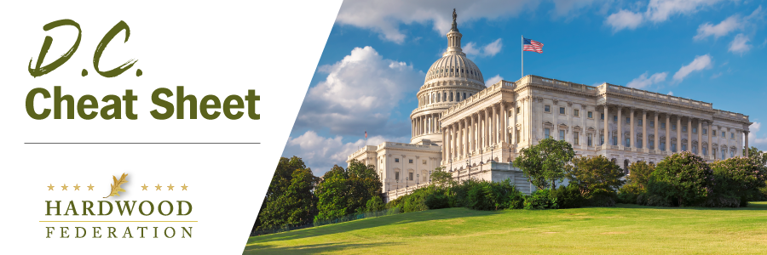

Quick Updates from Your HF Team

House Moves to Expand Standard Deduction
As House members work behind the scenes to prepare a tax package that may roll out this summer, small businesses aren’t the only parties likely to benefit from flexibility measures being considered by the tax writing committee. House Ways and Means Committee Chairman Jason Smith (R-MO), a longtime champion of small and family-owned businesses, including hardwood operations, has recently expressed support for a temporary raise of the standard deduction by $2000 for individual filers and $4000 for married couples. The legislation, known as the Working Families Tax Cut Act, offered by Reps. Nicole Malliotakis (R-NY) and Michelle Steel (R-CA) would apply the more robust deductions for the 2024 and 2025 filing years.
Labor Talks at West Coast Ports Continue to Stall
Despite efforts by industry and the Administration to resolve labor talks at the nation’s western ports, disruptions have occurred during the past week, including closure of the largest terminal at the Port of Long Beach on Monday. While the parties had reached tentative agreement on some key issues, including automation, back in April, there remains the unresolved issues of pay and benefits. The Hardwood Federation and its allies in the ocean shipping coalition have reached out to the Administration to urge resolution of the current impasse. The Federation will keep you posted on developments as they unfold.

