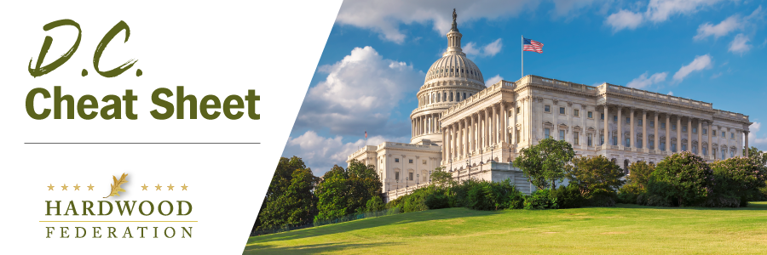

Quick Updates from Your HF Team

USFWS Issues “Framework” for Compliance with New NLEB Rule

In late January, the U.S. Fish and Wildlife Service (USFWS) extended the effective date of the final rule reclassifying the northern long-eared bat (NLEB) from threatened to endangered to March 31, 2023. Meanwhile, the USFWS is offering tools for stakeholders, including an Interim Consultation Framework, that will provide guidance through March 31, 2024, for projects taking place within the northern long-eared bat’s 37-state range. The goal of the Framework is to facilitate transition to the NLEB’s reclassification as accompanying regulations. For more information on the NLEB, please click here.

Senate Ag Committee Spotlights Efforts to Define “Old Growth Forests”
During last week’s Senate Ag Committee hearing, Ranking Member John Boozman (R-AK) expressed concern over the Biden Administration’s Executive Order on old growth forests. He characterized USDA’s effort to come up with a universal definition of “old growth” as “an impossible task that will only lead to litigation” that will divert resources “from important forest management activities.” He also pointed out that foresters have failed to agree on a universal definition for old growth, stating that the lack of consensus was an “Achilles heel” to the executive order. In late August, the Federation submitted comments to USDA urging federal regulators to avoid applying a “one size fits all” definition to old growth.
WOTUS Resolution of Disapproval
House Republicans are introducing a largely symbolic “Resolution of Disapproval” under the Congressional Review Act to rescind the Biden Administration’s “Waters of the United States” (WOTUS) rule that expands the scope of Clean Water Act permits for logging and other agricultural activities. The House will likely adopt the measure when it comes up for a floor vote, possibly as soon as Friday. Although passage in the Senate remains uncertain, the resolution is not likely to become law since it will require the President’s signature to cross the finish line.

Bonus Cheat Sheet Item: USDA Recognizes Biobased Products Day
On March 8, USDA kicked off the inaugural National Biobased Products Day and highlighted the accomplishments of people and organizations working to improve sustainability within the federal government. Moving forward, National Biobased Products Day will be an annual celebration to raise awareness of the benefits of biobased products, including biomass systems and other products that “foster economic development.” The celebration will also spotlight achievements made through USDA’s BioPreferred® Program, described as the federal governments “market accelerator for biobased products.”

Mark Your Calendar! The Federation Fly-In is Back, June 13 – 15, 2023
To sign up and reserve your room, please click HERE!.

