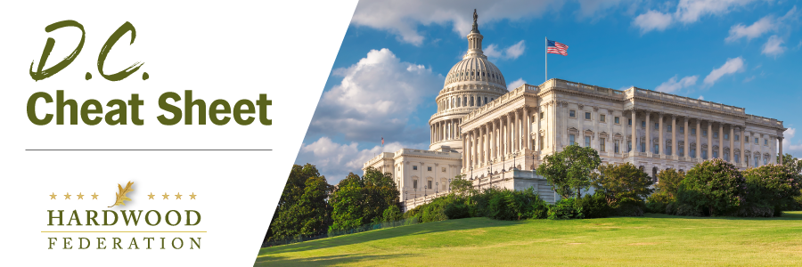
Quick Updates from Your HF Team

Manufacturers, Wood Products Industry Continue Push for Air Quality Flexibility
On October 31, the Hardwood Federation, the National Association of Manufacturers and 12 wood products industry allies sent a letter to White House Chief of Staff Jeffrey Zients to urge the Administration to retain the current air quality standard for fine particulate matter (PM 2.5) and reject proposals to tighten it. According to a study by the AF&PA and the American Wood Council, the proposal to drop the standard from 12 ug per cubic meter to 9 ug, the preferred outcome for the Administration, according to industry sources, would impose up to $900 million in compliance costs on the wood products sector. The industry letter, heavy on wood products signatories, follows in the wake of a Hardwood Federation meeting with White House officials at the Office of Management and Budget (OMB) identifying wildfires as the most significant threat to air quality as opposed to emissions from sawmills and other sources.
Lawmakers Pivot to FY 2024 Spending Bills
The Senate continues work on a three piece “mini-bus” appropriations package including Ag-FDA, which contains provisions funding USDA and critical rural development programs. To clarify, key hardwood programs such as the Market Access and Foreign Market Development Programs that promote exports will be funded in the farm bill, which should see some movement during the weeks ahead, following election of House Speaker Johnson (R-LA). Also on the Senate side, the Appropriations Committee has passed a bill that includes pro-industry language to direct the Forest Products Labor to conduct a study quantifying the amount of carbon stored in wood products. The Federation will keep you posted on developments related to the spending bills as they unfold.
Hardwoods Launch First Industry Meeting to Counter E.U. Import Regs
On October 30, the Federation co-hosted a meeting with AF&PA about the hardwood and paper sectors’ activities related to new rules coming from the E.U. that will hinder the import of U.S. wood products by requiring a cumbersome geo-location certification. The ostensible purpose of the rules is to promote “deforestation free” products, but industry and federal officials agree that they will operate more as a trade barrier. The American Hardwood Export Council (AHEC) shared proposed solutions to expedite compliance, including definitional changes to the new rules and development of an App based solution to the geolocation reporting requirements. Other sectors participating included softwood, hardwood panel & veneer, pallets, pellets, and landowners, all of which agreed to meet on a regular basis with joint leadership from the Federation, AHEC and AF&PA.

