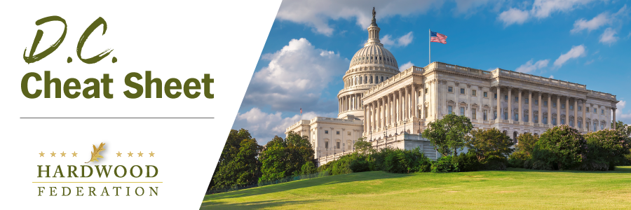

Quick Updates from Your HF Team
Senate Steps in to Push Temporary Funding Measure, Avoid Shutdown
With three days remaining to hammer out a deal to avoid a partial government shutdown, the Senate has stepped in to initiate a Continuing Resolution (CR) that would fund federal operations through November 17. Although a relatively straight-forward measure, the CR does include Ukraine funding that will draw opposition from many House Republicans, complicating a path forward once the measure clears the Senate. On the House side, the leadership team, working with members of the Freedom Caucus and Problem Solvers Caucus, have fashioned a month-long CR that would fund the government roughly through October, but a consensus on that plan has not been forged. We will keep you apprised of developments.
House Lawmakers Introduce White Oak Resilience Act
On September 21, House lawmakers introduced the bipartisan White Oak Resilience Act (H.R. 5582). The legislation would, among other things, establish pilot programs to regenerate the nation’s rapidly aging white oak forests. According to the White Oak Initiative, “American white oak is a foundational tree species, currently occupying more than 104 million acres of public and private forestland across much of the eastern and central United States.” The legislation intends to improve land management practices that will support the sustainability of white oak trees, which forms the foundation of many forest ecosystems while providing jobs for the manufacture of flooring, and barrels that store wine and spirits.
Forest Products Industry Shares Clean Air Act Perspectives with Congress
On September 19, the American Forest & Paper Association and American Wood Council testified before a House Energy & Commerce panel, outlining reasons why EPA should use its discretionary authority to reject a proposal that would reduce concentrations of fine particles (PM 2.5) to levels found naturally in the environment. Industry also pointed out that moving forward with an unnecessary, new standard would further complicate the “permitting gridlock” currently plaguing the agency and impose more red tape on paper mills operating in or near counties currently in non-compliance with current rules. The congressional testimony is consistent with messages expressed in a letter to EPA from the Hardwood Federation and 33 allied groups, warning federal regulators that stricter air quality regulations would threaten nearly one million jobs nationwide.

