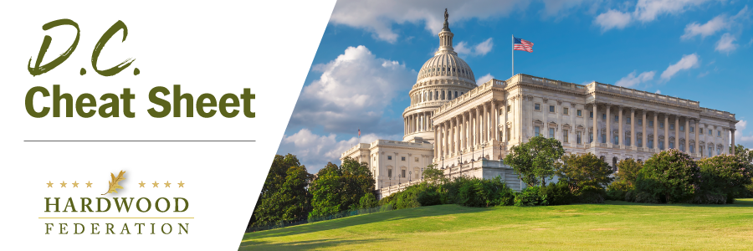

Quick Updates from Your HF Team
Ocean Shipping Reform Sails Toward the Finish Line!
As Congress returned from the Memorial Day work break, House Majority Leader Steny Hoyer (D-MD) announced that the House will vote on the Senate-passed version of the “Ocean Shipping Reform Act” (OSRA), bypassing an extended negotiation on a final bill. Congressional leaders on both sides of the aisle are looking for easy wins leading up to the November election, especially on bills that will help untangle transportation bottlenecks. A vote on final passage is expected to take place the week of June 13, after which Congress will send the bill to the President for signature. Stay tuned for updates on what’s shaping up to be a victory lap for industry next week.
HF, Allies Push $10 million Raise for Forestry Stewardship
On May 24, the Federation joined more than 50 industry groups in a letter to Congressional budget leaders recommending $22 million to fund the Forest Stewardship Program at USDA. This represents an increase from $12 million enacted for 2022. Industry argues that the fund is a necessary tool to, among other things, coordinate state and local sustainable management efforts, provide needed raw materials to local wood mills and operations, and promote wildlife protection.

Legislation Addressing Northern Long-Eared Bat (NLEB) Listing Imminent
Rep. Pete Stauber (R-MN-08) is expected to roll out legislation next week that would make permanent a federal rule currently on the books that allows forest management practices in the NLEB’s 38-state range to continue once the bat is listed as “endangered." We will have more info next week on this bill but wanted to flag this as an effort that we hope will be bipartisan. At this time a path forward for the legislation is unclear. The Hardwood Federation worked hard in 2014-15 to secure a workable solution for both protecting the bat and preserving the ability for forest landowners to sustainably manage their forest landholdings in the bat’s habitat range.

